1. **Create the following table with the given data as follows.**

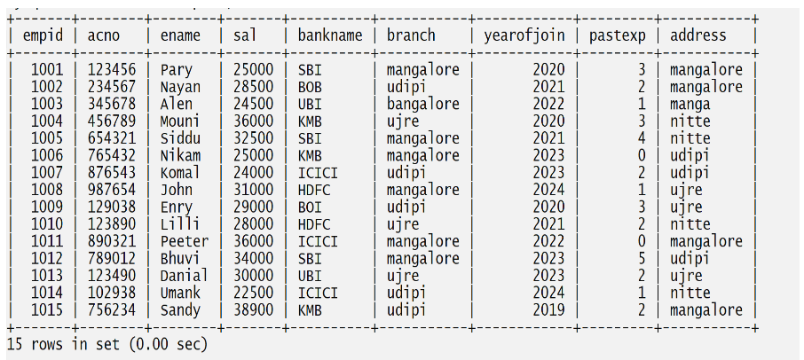

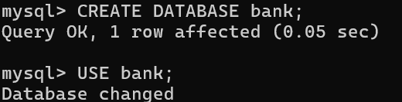

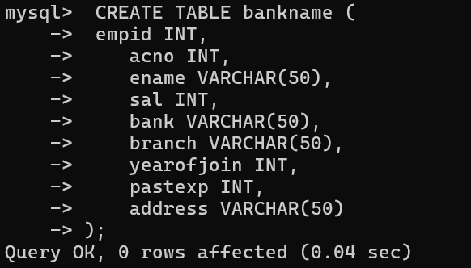

**2.Write a query to display all the records from the table.**

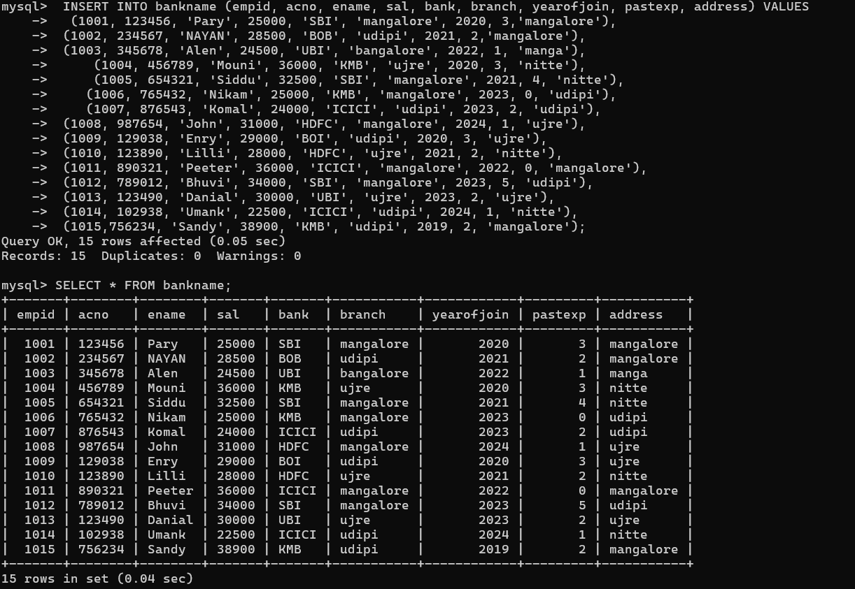

**3.Write a query to display all the records from the table, whose branch and address both are the same.**

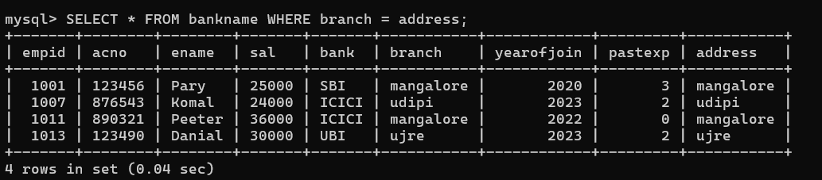

**4. Write a query to display employee acno, ename, bankname, and branch details whose salary is more than 30000.**

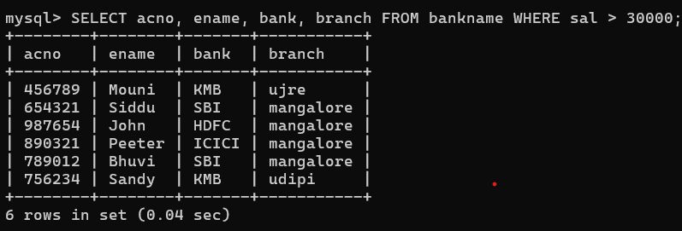

**5.Write a query to display employee records who are earning less than 25000**

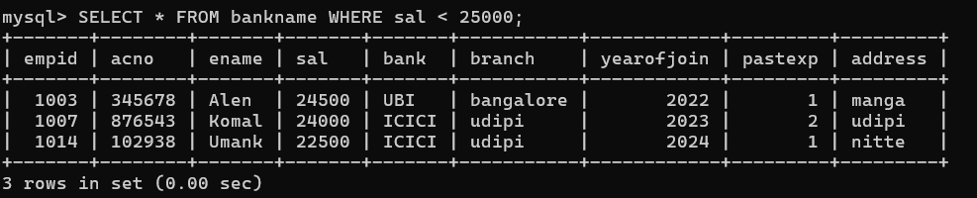

**6.Write a query to display the employee record of who is earning the highest salary**

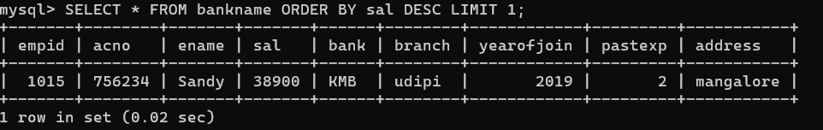**.**

**7. Write a query to display the employee name who is earning less salary.**

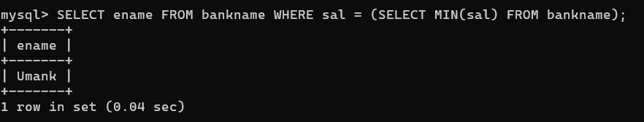

**8. Write a query to the employee ename, acno, and bankname who are earning in between 25000 and 32000 (both are included).**

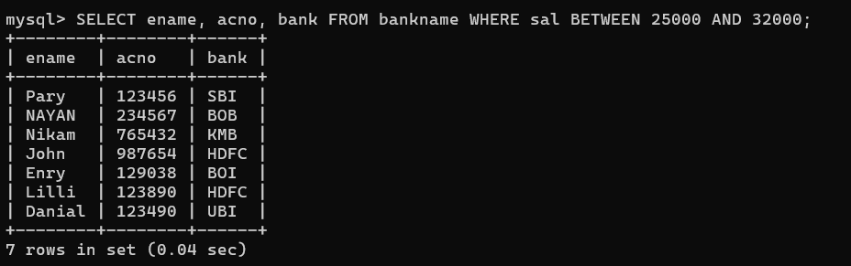

**9. Write a query to display eid, ename, sal, acno who have an account in SBI bank.**

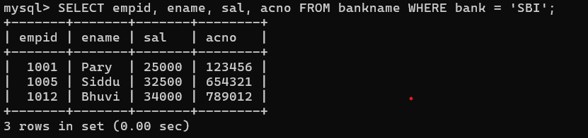

**10. Write a query to display eid, ename, sal, acno who have an account in ICICI bank and from udipi branch.**

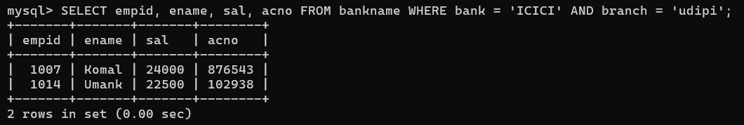

**11. Write a query to display eid, ename, sal, acno who have joined before 2023(2023 is excluded).**

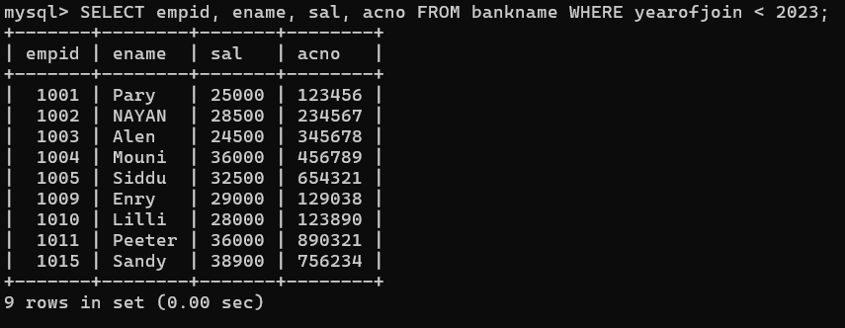

**12. Write a query to display eid, ename, sal, acno, bankname and branch who have an account in SBI bank and joined after 2022.**

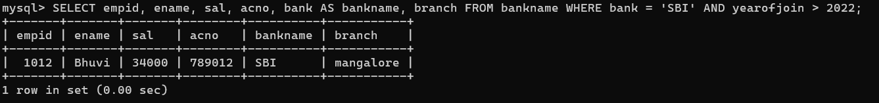

**13. Write a query to display eid, ename, sal, acno,address who have joined early from mangalore.**



**14. Write a query to display eid, ename, sal, acno who have an account in SBI bank and whose name starts with ‘p’.**

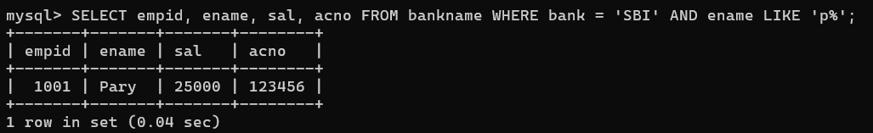

**15. Write a query to display the number of employees having the same salary and that salary from the table.**

